Grade 8: Module 1: Unit 2: Lesson 9
Close Reading: Paragraph 1 of “Refugee and Immigrant Children: A Comparison” (from “Refugee Children in Canada: Searching for Identity”)

Long-Term Targets Addressed (Based on NYSP12 ELA CCLS)
I can cite text-based evidence that provides the strongest support for an analysis of literary text. (RI.8.1)
I can determine a theme or the central ideas of an informational text. (RI.8.2)
I can analyze the structure of a specific paragraph in a text (including the role of particular sentences in developing and refining a key concept). (RI.8.5)
I can read above-grade informational texts with scaffolding and support. (RI.8.10)
Supporting Learning Targets | Ongoing Assessment
- I can find the gist of the first paragraph of “Refugee and Immigrant Children: A Comparison.”  - I can analyze how specific words, phrases, and sentences help me understand how refugee and immigrant children are similar.  - I can cite evidence to explain the similarities and differences between refugee children and immigrant children. | - Answers to text-dependent questions, Part A

Agenda | Teaching Notes
- Opening  - Engaging the Reader: “Give One, Get One” about Pages 213–234 of Inside Out & Back Again (5 minutes)  - Unpacking Learning Targets (2 minutes)  - Work Time  - Vocabulary and Predictions Before Reading: Venn Diagram to Compare Refugees and Immigrants (8 minutes)  - Reading Aloud and Rereading for Gist: Paragraph 1 of “Refugee and Immigrant Children: A Comparison” (10 minutes)  - Rereading and Text Dependent Questions (15 minutes)  - Closing and Assessment  - Mix and Mingle: A Similarity in How Refugees and Immigrants Adapt (5 minutes)  - Homework  - Complete the homework question at the very bottom of the “Refugee and Immigrant Children: A Comparison” Paragraph 1 Text-Dependent Questions.  - Complete a first read of pages 238–247. Take notes (in your journals) using the Structured Notes graphic organizer. | - This lesson introduces students to one section of the article “Refugee Children in Canada: Searching for Identity.” The section is entitled “Refugee and Immigrant Children: A Comparison,” which describes the similarities in the adaptation process of refugees and immigrants. This full article is very complex. Students read only this one specific section that compares refugees and immigrants. This section of the text was chosen because it best aligns with Ha’s experiences in the novel.  - Across the next six lessons, students will work closely with the four paragraphs in this section, “Refugee and Immigrant Children: A Comparison.” The text is broken into three chunks: Paragraph 1, Paragraphs 2–3, and Paragraph 4. Students spend two days with each chunk. On the first day of each two-day cycle, they read closely just to understand the complex text. For homework, they think and write about one key sentence or phrase. On the second day of each two-day cycle, they revisit the text, answering additional text-dependent questions and applying the concepts to specific poems in the novel. In advance: Review the first paragraph of the “Refugee and Immigrant Children: A Comparison” section, as well as the note-catchers in Lessons 9 and 10.  - Consider arranging a session in advance during which struggling readers can preview the article. This will support comprehension as they read it a second time, and eliminate any issue with the possibility that the time allotted for reading is not sufficient. Students can highlight or annotate information that they can use in preparation for the lesson.  - Remind students of their strong work with “The Vietnam Wars” text in Unit 1. This text is even more challenging, but many of the strategies they used to make sense of that text will serve them well here too. Remind students that close reading is a challenge. They can all do it by working at it, and they will rise to the challenge. Consider which students might need access to the Vocabulary Guide for these lessons to support their acquisition of text. Because the homework for this lesson includes an independent first-read of text, there is also a separate glossary of Additional Words from Assigned Reading. The glossaries can be provided during an additional support class in advance, with time to pre-teach the words, or modified to be used by students independently (see supporting materials).  - In advance: Review “Give One, Get One” and “Mix and Mingle” protocols. Consider adjusting the protocols and posting them, so that the expectations can be clearly presented to all students.

Lesson Vocabulary | Materials
refugee, refuge, immigrant, significant, disruptive, interrupt, sense of identity, generational gap, cultural gap | - Inside Out & Back Again (book; one per student)  - Inside Out Anchor Chart and Back Again Anchor Chart (begun in Lesson 8)  - “Refugee and Immigrant Children: A Comparison” section from the full article “Refugee Children in Canada: Searching for Identity” (one per student)  - Prefixes Note-Catcher (begun in Lesson 3)  - Similarities and Differences in How Refugees and Immigrants Adapt Anchor Chart (new; co-created with students in Work Time A; see Supporting Materials)  - “Refugee and Immigrant Children: A Comparison”: Paragraph 1 Text-Dependent Questions, Part A (one per student and one to display)  - Homework question (one per student)  Optional Materials  - Vocabulary Guide  - Word Parts Enhancement Activity: Word Parts Triangle  - Similarities and Differences between Immigrants and Refugees (Alternate Version)  - “Refugee and Immigrant Children: A Comparison”: Paragraph 1 Text-Dependent Questions, Part A (Alternate Version)

Opening | Meeting Students’ Needs
A. Engaging the Reader: “Give One, Get One” about Pages 213–234 of Inside Out & Back Again (5 minutes)  - Tell students that they are going to do a simple interactive activity to share some of their learning from their homework reading.  - Explain “Give One, Get One” and display the expectations. Ask students to circulate until you give the signal (music or a hand signal), about 15 seconds later. When the music stops, they are to turn to the person closest to them and share one piece of evidence they recorded on their Structured Notes organizer from reading pages 213–234 that reveals an aspect of Ha’s dynamic character. They give one piece of evidence and receive one piece of evidence from the person they are speaking to. Repeat three times. | - If time permits, students may benefit from having the instructions for this opening activity posted as “do now” when they arrive in class. Students could review, reread, or add to their notes from last night’s homework in preparation for the “Give One, Get One” activity.

Opening (continued) | Meeting Students’ Needs
- Cold call on a few students to share their evidence with the whole group. Invite students to suggest which anchor chart to record the evidence on—Inside Out or Back Again anchor charts. Confirm whether the rest of the group agrees and record the evidence on the appropriate anchor chart.  Note: If the above Give One, Get One activity is not appropriate for your group, consider doing the same thing but with an inner circle and outer circle. Divide the group in half—one half makes an inner circle, facing out, and the other half makes a circle around them, facing in. Students facing each other give one and get one, before the inner moves one step to the left. Students then give one and get one with the next person. | - Some students might benefit from having posted expectations for the “Give One, Get One” activity.  - Use of protocols like Give One, Get One allows for total participation of students. It encourages critical thinking, collaboration, and social construction of knowledge. It also helps students to practice their speaking and listening skills.
B. Unpacking Learning Targets (2 minutes)  - Post the learning target for students and invite them to follow along silently as you read aloud:  - “I can find the gist of the first paragraph of ‘Refugee and Immigrant Children: A Comparison.’”  - “I can analyze how specific words, phrases, and sentences help me understand how refugee and immigrant children are similar.”  - “I can cite evidence to explain the similarities and differences between refugee children and immigrant children.”  - Tell students that today they will be reading part of an informational text that will help them meet these targets. Ask the class to Think-Pair-Share:  - “How might reading an informational text help us understand Ha?”  - Listen for: “By reading this text we are building knowledge about the universal refugee experience of turning inside out and back again. This is what Ha is going through.”  - Remind students that this information helps them learn about the world, and will be important when they write their end of unit assessment essay: Ha is just one unique (fictional) example of the more universal refugee experience. | - Posting learning targets for students allows them to reference them throughout the lesson to check their understanding. The learning targets also provide a reminder to students and teachers about the intended learning behind a given lesson or activity.  - Some students may benefit from referring to the Lesson Vocabulary Guide (see supporting materials).  - Circulating teachers and aides should gently encourage struggling students to use their glossaries as needed throughout the lesson.

Work Time | Meeting Students’ Needs
A. Vocabulary and Predictions Before Reading: Venn Diagram to Compare Refugees and Immigrants  (8 minutes)  - Distribute and focus students on the “Refugee and Immigrant Children: A Comparison” section from the full article “Refugee Children in Canada: Searching for Identity.”  - Explain that this is one section from an article about refugee children who have fled their home country and then come to Canada to make a new home. Tell students that it is a very complex piece of text, so they are going to look at only a small section of it. Today they will dig in to a single paragraph. In Lesson 10, they will think more about how the important concepts in this paragraph apply to Ha.  - Point out the word refugee, and ask students:  - “We have been talking about refugees for a few weeks now. What is a refugee?”  - “What is a refuge?”  - Some students may know that a refuge is a place of safety. Clarify if needed. Ask:  - “So how are these two words related to each other?”  - Cold call or ask for volunteers to share their responses. Listen for: “A refugee is someone who flees his or her home to go to a place that is safe.”  - Focus on the word immigrant. Briefly review the work students did in Lesson 3, when they studied a word that sounds very similar, emigrate. Ask for a volunteer to remind the class:  - “What did we learn the word emigrate means?”  - Listen for the response: “To move out.” Cold call a student to answer,  - “What word root do you see in both words? What does migrant mean?”  - Listen for a response such as: “Someone who moves.” Cold call a student to answer:  - “So, what is the prefix added to that word?”  - Listen for: “im-.” Probe:  - “What might the prefix “im-” mean?” | - Circulating teachers and aides should gently encourage struggling students to use their glossaries as needed throughout the lesson.  - Consider which students might benefit from additional work with prefixes, word roots, and suffixes. A Word Parts Enhancement Activity: Word Parts Triangle is available in the supplementary materials.

Work Time (continued) | Meeting Students’ Needs
- Invite volunteers to respond; listen for someone to say: “Not.” Tell them if needed. Say: “That means, when we put that prefix ‘im-,’ which means ‘not,’ with that root, ‘migrant,’ we come up with a word that specifically means someone who is not moving.”  - Clarify that an immigrant is someone who has chosen to move to a new country, but this person then settles where he or she has moved—and doesn’t move again. Encourage students to add the prefix “im” to their Prefixes Note-Catcher.  - Paraphrase to clarify for all, saying something like: “So both immigrants and refugees move to another place, but they move for different reasons. Ask:  - “So what is the difference between a refugee and an immigrant?”  - Listen for: “A refugee is someone who has been forced to move—to flee. But an immigrant has chosen to move.”  - “So is Ha a refugee or an immigrant? How do you know?”  - (Students should easily recognize that Ha is a refugee: She fled her home quickly, because of impending danger.)  - Invite students to get into Numbered Heads groups with odd numbers pairing up and even numbers pairing up.  - Post questions one at a time. Invite students to Think-Pair-Share and record their suggested answers on the Similarities and Differences in How Refugees and Immigrants Adapt anchor chart:  - “So what common challenges do you think refugees and immigrants both face?”  - “Which challenges are unique to refugees?”  - “Which challenges are unique to immigrants?” | - Some students might benefit from seeing this lesson presented or recorded as a Venn diagram. This alternate version can be created in advance in a separate class for students who might need it. See the Similarities and Differences between Immigrants and Refugees (Alternate Version) available in the supplemental materials.

Work Time (continued) | Meeting Students’ Needs
B. Reading Aloud and Rereading for Gist: Paragraph 1 of “Refugee and Immigrant Children: A Comparison” (10 minutes)  - Display the first paragraph of the section “Refugee and Immigrant Children: A Comparison.”  - Remind students that when text is really challenging, it is often helpful to chunk it into smaller sections. Today, they will hear you read just one paragraph of this section of the text, and then they will have time to think, talk, and annotate for gist.  - Read just paragraph 1 in this section aloud as students read silently.  - Then ask students to reread the paragraph on their own. Emphasize how important it is to reread with a text this challenging. It is fine if it’s still feeling hard.  - Ask students to Think-Pair-Share:  - “So what is your initial sense of what this paragraph is mostly about?”  - Invite students to annotate the first paragraph for the gist based on their pair discussion.  - Invite volunteers to share their gist with the whole group. Listen for, “The similarities in the challenges immigrant children and refugee children face in a new country.” | - Hearing a complex text read slowly, fluently, and without interruption or explanation promotes fluency for students: They are hearing a strong reader read the text aloud with accuracy and expression, and are simultaneously looking at and thinking about the words on the printed page. Be sure to set clear expectations that students read along silently as you read the text aloud.  - To further support ELLs, consider providing definitions of challenging vocabulary in students’ home language. Resources such as Google Translate and bilingual translation dictionaries can assist with one-word translation.  - Asking students to identify challenging vocabulary helps them to monitor their understanding of a complex text.
C. Rereading and Text Dependent Questions (15 minutes)  - Refocus the group. Display and distribute the “Refugee and Immigrant Children: A Comparison” Paragraph 1 Text-Dependent Questions, Part A.  - Reread just the first sentence of paragraph 1: “Refugee and immigrant children in Canada have significant similarities.”  - Focus on the first text-dependent question. | - Text-dependent questions can be answered only by referring explicitly to the text being read. This encourages students to reread the text for further analysis and allows for a deeper understanding.
Work Time (continued) | Meeting Students’ Needs
- Invite students to read the question with you.  - Direct their attention to the part of the text that the vocabulary was taken from so they can read it in context.  - Invite pairs to discuss what they think the answer might be.  - Invite pairs to record their ideas on their note-catcher.  - Select a “numbered head” to share his or her answer with the whole group and clarify what it means where  necessary.  - Invite students to revise their notes where they are incorrect.  - Reread the second sentence of paragraph 1: “Both groups must deal with migration, which represents a disruptive loss to one’s life.”  - Invite students to Think-Pair-Share:  - “We talked about migration earlier in relation to the word immigrants. What does migration mean?”  - “Let’s look at the disruptive losses part. So what does disruptive mean?”  - Listen for: “When something is disruptive, it stops things from happening.” Point out to students that the word disrupt has a similar root as the word interrupt. “Rupt” means to break.  - Focus students on the longest sentence in the paragraph. Reread this sentence as students read along silently: “Both refugee and immigrant children may encounter society’s discrimination and racism, and both have to accomplish the central task of childhood and adolescence—developing a sense of identity—while trying to bridge generational and cultural gaps.”  - Focus on the remaining text-dependent questions.  - Invite students to read the question with you.  - Direct their attention to the appropriate part of the text.  - Invite pairs to discuss what they think the answer might be.  - Invite pairs to record their ideas on their note-catcher.  - Select a “numbered head” to share his or her answer with the whole group and clarify what it means where necessary.  - Invite students to revise their notes where they are incorrect.  - Move on to the next question. | - Some students might benefit from having access to the “Refugee and Immigrant Children: A Comparison”: Paragraph 1 Text-Dependent Questions, Part A (Alternate Version) found in the supporting materials.

Closing and Assessment | Meeting Students’ Needs
A. Mix and Mingle: A Similarity in How Refugees and Immigrants Adapt (5 minutes)  - Ask students to skim the paragraph and underline every time the word both appears. Point out that the author uses this word five times in the paragraph. The author was choosing words carefully to signal to readers that there are five main similarities between how refugees and immigrants adapt.  - Ask students to take a few minutes to reread and think about one similarity in how refugees and immigrants adapt that they think is the most important and why.  - Mix and Mingle:  - Invite students to move around the room for 15 seconds.  - Use the signal (music or a hand signal) to get students to stop and share what they consider to be the most important similarity between how refugees and immigrants adapt with the person closest to them. Remind students to justify why they think that is the most important similarity.  - Repeat until students have shared their similarity three times.  - Distribute homework question. | - Some students might benefit from having posted expectations for the “Mix and Mingle” activity.

Homework | Meeting Students’ Needs
- We discussed what disruptive loss means in this lesson. Complete the homework question at the very bottom of the “Refugee and Immigrant Children: A Comparison” Paragraph 1 Text-Dependent Questions.  - Complete a first read of pages 238-247. Take notes (in your journals) using the Structured Notes graphic organizer. Focus on key details and the strongest evidence that reveal the challenges Ha is facing and her dynamic character, plus new or important vocabulary that helps you understand the specific challenges she faces as a refugee. | - Consider which students might need access to the Additional Words from the Assigned Reading in the Vocabulary Guide (see supporting materials).  - Some students may benefit from a separate session in which they work on the Structured Notes with teacher support.

Grade 8: Module 1: Unit 2: Lesson 9
Supporting Materials
Refugee and Immigrant Children: A Comparison

Refugee and immigrant children in Canada have significant similarities. Both groups must deal with migration, which represents a disruptive loss to one’s life. Once in Canada, they both have to endure the “push-and-pull” forces of home and school, which often work in opposite directions. At school they share with other adolescents the desire to be accepted by their peer group. At home, both groups may experience a role and dependency reversal in which they may function as interpreters and “cultural brokers” for their parents. Both refugee and immigrant children may encounter society’s discrimination and racism, and both have to accomplish the central task of childhood and adolescence – developing a sense of identity – while trying to bridge generational and cultural gaps. Perhaps the greatest threat to these children is not the stress of belonging to two cultures but the stress of belonging to none (Lee, 1988).

Successful adaptation can bring with it the opportunity for growth. How well children adapt is influenced by several factors, including age at arrival, individual resiliency, and reception by the host community and society. One key factor in determining success is the reception of newcomers by the host society. Settlement support services, schools, health and social services, and the community at large play a crucial role in assisting and supporting children to adjust and integrate into Canadian society (Task Force on Mental Health Issues Affecting Immigrants and Refugees, 1988).

Several key characteristics affect the adaptation of refugee children to a larger extent than immigrant children. First, refugee children often have experienced the tragedy and trauma of war, including persecution, dangerous escapes, and prolonged stays in refugee camps. Some have witnessed killings, torture, and rape – including atrocities against family members. Others have been forced to serve as soldiers. Some have lost many members of their families and many have lost everything that was familiar to them.

Typically, immigrants can, at least, envision the possibility of returning to their countries; most refugees cannot. It is not only natural that refugee children, along with their families, go through a process of mourning those losses. The grieving process in refugee children, however, is seldom recognized as such. This may be attributed to a long-held belief that children adapt quickly, bolstered by the tendency of children to not express their sadness and mourning in words. Although these children may not know the concept of being homesick; they feel it all the same. Although some would not talk about their experience for fear of upsetting their parents, perhaps it is also true that many do not talk because we do not listen.

“Refugee Children in Canada: Searching for Identity” by Ana Marie Fantino and Alice Colak (CHILD WELFARE, Vol. LXXX, #5, September/2001 Child Welfare October, © League of America; pages 587-596).

Similarities | Unique to Refugees | Unique to Immigrants

Name:
Date:

Questions | Notes
The text says, “Refugee and immigrant children in Canada have significant similarities.”

What does significant mean?

The text says, “Both groups must deal with migration, which represents a disruptive loss to one’s life.”

What does migration mean?

What does disruptive mean?

Questions | Notes
The text says, “Both refugee and immigrant children may encounter society’s discrimination and racism, and both have to accomplish the central task of childhood and adolescence—developing a sense of identity —while trying to bridge generational and cultural gaps.”

What is a sense of identity?
What is a generational gap?

What is a cultural gap?

Now that you have looked at individual parts of this really long sentence, reread that same sentence. Paraphrase the sentence in your own words.

The text says, “Refugee and immigrant children in Canada have significant similarities.
Both groups must deal with migration, which represents a disruptive loss to one’s life.”

In your own words, explain what it means to have a “disruptive loss to one’s life.
How has migration been a disruptive loss for Ha in the novel Inside Out & Back Again?

Grade 8: Module 1: Unit 2: Lesson 9
OPTIONAl MAterials

Lesson Vocabulary Guide

Word | Definition
refugee (n) + | someone who has been forced to leave his or her country in order to escape war, persecution, or natural disaster
refuge (n) | a place of safety
immigrant (n) | a person who chooses to move to a different country
significant (adj) | important
disruptive (adj) | stopping things from happening
interrupt (v) | to cause an activity to stop
sense of identity | an person's understanding of who he or she is
generational gap | a difference between two generations which keeps them from understanding or relating to each other
cultural gap | a difference between two cultures which keeps them from understanding or relating to each other
+ Repeated from earlier in the module

Additional Words from Assigned Reading

Word | Page | Definition
consulted (v) | 237 | asked for information or advice
monastery (v) | 240 | a place where monks, people who take religious vows, live
whim (n) | 241 | a sudden change of mind

Word Parts Enhancement Activity: Word Parts Triangle

Directions:
Provide the following enhancement activity for students who need additional work with word parts.
- Provide or ask students to brainstorm the definitions of prefix, suffix, and word root.
- Provide or ask students to share what they know, from recent lessons or their past learning, about how word parts can help them determine the meanings of words.
- Guide students through the process of creating a graphic organizer similar to the one below. A sample is provided.
- Consider having students keep these activities for reference or display.

Word:

Prefix
Suffix
Root
Meaning
Meaning
Meaning

Word used in Context:

Definition:

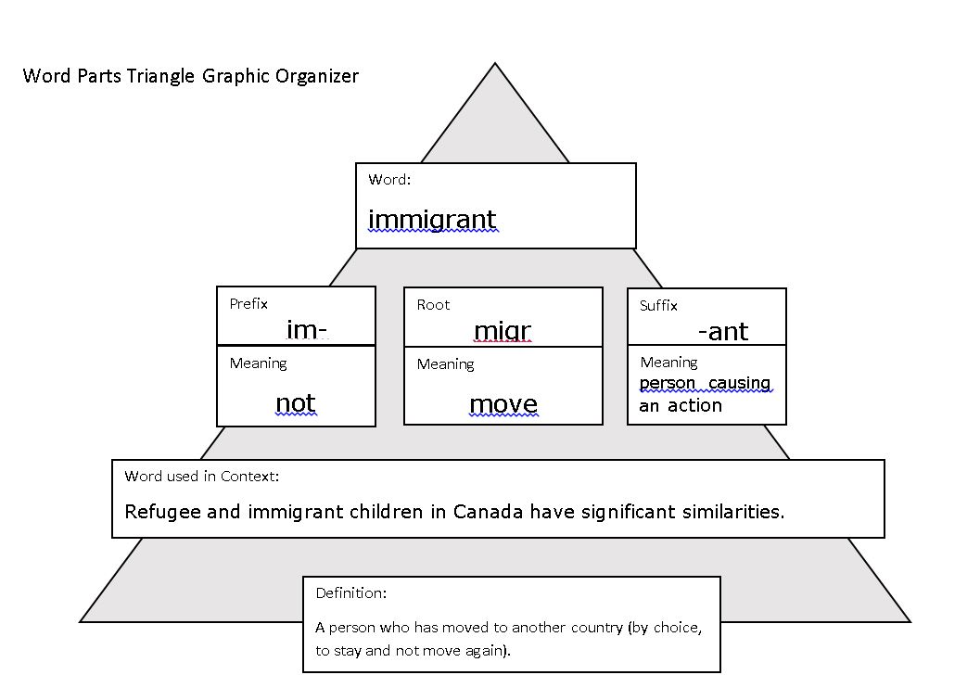

The following page includes a graphic organizer that can serve as a starting point or an alternate for students who might benefit from this visual. Adapt it for use it in conjunction with the Similarities and Differences in How Refugees and Immigrants Adapt Anchor Chart, and the accompanying Work Time A directions. Adjust it based on the needs of your students.

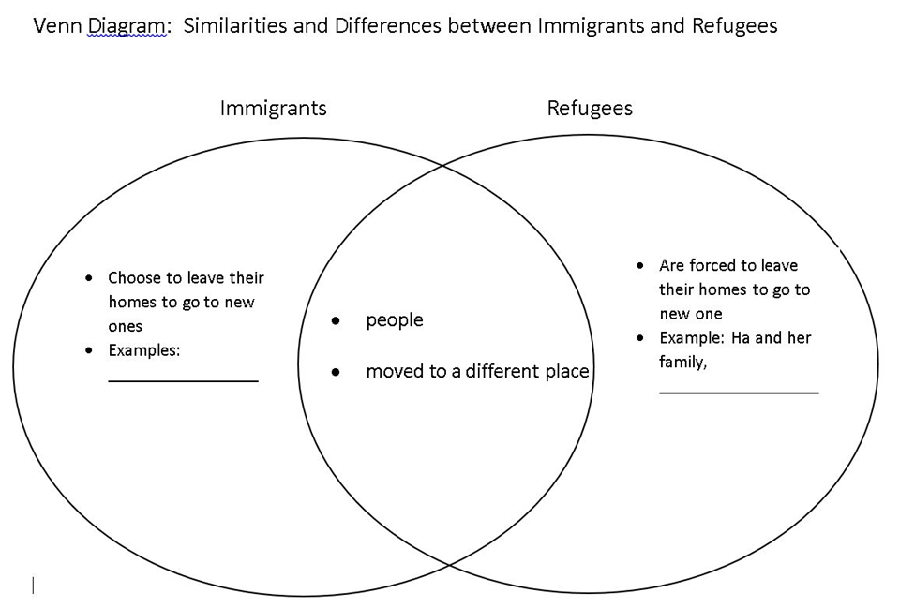

Note to teacher: The next pages include a scaffolded version of the text-dependent questions for this lesson, including hints. Before distributing it, adjust it to fit the needs of your students, including directions, content, and space needed to write. Students may need additional instruction to support their use of this tool.

Name:
Date:

Questions | Notes
The text says, “Refugee and immigrant children in Canada have significant similarities.”  What does significant mean? | Hint: A similar word, signify, means to be a sign of something important.
The text says, “Both groups must deal with migration, which represents a disruptive loss to one’s life.”  What does migration mean? | Hint: A similar word, immigrant, is a person who moves to a new country to live.
What does disruptive mean? | Hint: A similar word, interrupt, means to cause an activity to stop.

Questions | Notes
The text says, “Both refugee and immigrant children may encounter society’s discrimination and racism, and both have to accomplish the central task of childhood and adolescence—developing a sense of identity —while trying to bridge generational and cultural gaps.”  What is a sense of identity? | Hint: A similar word, identify, means to determine who or what something is.
What is a generational gap? | Hint: A similar word, generation, means  a group of people born at the same time.
What is a cultural gap? | Hint: A similar word, culture, means the beliefs and customs of a particular society.
Now that you have looked at individual parts of this really long sentence, reread that same sentence. Paraphrase the sentence in your own words.

